Beta-diversity re-analysed

Analyses of Beta diversity with modified qualitative categorical variable “PFOS” which distinguishes the direct exposure of PFOS by the value “ctrl” for control conditions and “PFOS” for PFOS exposure conditions. This variable distance itself from “treatment” by categorizing all Day 0 samples as “ctrl” regardless of rats being grouped in a PFOS exposure group, as direct exposure is only applied after Day 0. In a longitudinal analysis for beta-diversity using a factorial impact score, like PERMANOVA provides, this is an important distinction as non-exposed samples would otherwise be adding to the pool of exposed samples in the case of including Day 0 in the analysis.

# Faeces

## All data

1. Below show all the data collected from faeces in weighted metrices (Bray-Curtis and weighted UniFrac) and unweighted metrices (Jaccard and unweighted UniFrac (normal UniFrac)).  
    Not much difference is seen compared to the last analysis. Major factorial impacts are seen from ***feed*** and ***time***, as well as both together, while ***PFOS***-treatment has a significant but smaller impact for both weighted and unweighted metrices. The most noticeable difference from the variable change is a closer-to-significant impact from feed:PFOS combined (Bray: old p = 0.129, new p = 0.089; Unif: old p = 0.05, new p = 0.015), while for UniFrac PFOS treatment has no significant impact at all, which might arise from the inverse impact of the already biased LF-PFOS on Day 0, now spreading the difference over the control group and hence lowering the distance to PFOS-treated samples. Despite this counteracting factor, PFOS treatment does have a significant impact on both Bray-Curtis and Jaccard, while the impact on Weighted UniFrac is only close to significant with p = 0.064.  
   However, as we talked about this analysis does not make a lot of sense as all data is handled at the same time as well as the biased LF-Day 0 data.

|  |  |
| --- | --- |
| **All data** | |
| **Bray-Curtis** | **Jaccard** |
|  |  |
| adonis2(formula = dist.used ~ day * feed * PFOS, data = mdat, permutations = 999, na.action = na.omit)  Df SumOfSqs R2 F Pr(>F)  day 4 1.844 0.04572 3.0500 0.001 ***  feed 1 12.871 0.31922 85.1749 0.001 ***  PFOS 1 0.411 0.01020 2.7225 0.023 *  day:feed 4 1.482 0.03676 2.4521 0.003 **  day:PFOS 3 0.380 0.00942 0.8379 0.618  feed:PFOS 1 0.269 0.00668 1.7825 0.089 .  day:feed:PFOS 3 0.396 0.00981 0.8726 0.582  Residual 150 22.668 0.56218  Total 167 40.321 1.00000  ---  Signif. codes: 0 ‘***’ 0.001 ‘**’ 0.01 ‘*’ 0.05 ‘.’ 0.1 ‘ ’ 1 | adonis2(formula = dist.used ~ day * feed * PFOS, data = mdat, permutations = 999, na.action = na.omit)  Df SumOfSqs R2 F Pr(>F)  day 4 1.3661 0.04453 2.1805 0.002 **  feed 1 3.6810 0.12000 23.5014 0.001 ***  PFOS 1 0.3109 0.01013 1.9848 0.018 *  day:feed 4 0.8399 0.02738 1.3405 0.039 *  day:PFOS 3 0.3189 0.01040 0.6788 0.975  feed:PFOS 1 0.2990 0.00975 1.9092 0.019 *  day:feed:PFOS 3 0.3654 0.01191 0.7777 0.906  Residual 150 23.4941 0.76590  Total 167 30.6752 1.00000  ---  Signif. codes: 0 ‘***’ 0.001 ‘**’ 0.01 ‘*’ 0.05 ‘.’ 0.1 ‘ ’ 1 |
| **Weighted UniFrac** | **(unweighted) UniFrac** |
|  |  |
| adonis2(formula = dist.used ~ day * feed * PFOS, data = mdat, permutations = 999, na.action = na.omit)  Df SumOfSqs R2 F Pr(>F)  day 4 0.9807 0.05497 3.2516 0.001 ***  feed 1 4.3600 0.24440 57.8252 0.001 ***  PFOS 1 0.1767 0.00991 2.3440 0.064 .  day:feed 4 0.6243 0.03499 2.0698 0.020 *  day:PFOS 3 0.1821 0.01021 0.8049 0.596  feed:PFOS 1 0.1029 0.00577 1.3648 0.206  day:feed:PFOS 3 0.1032 0.00578 0.4561 0.942  Residual 150 11.3101 0.63397  Total 167 17.8399 1.00000  ---  Signif. codes: 0 ‘***’ 0.001 ‘**’ 0.01 ‘*’ 0.05 ‘.’ 0.1 ‘ ’ 1 | adonis2(formula = dist.used ~ day * feed * PFOS, data = mdat, permutations = 999, na.action = na.omit)  Df SumOfSqs R2 F Pr(>F)  day 4 0.5756 0.05332 2.7778 0.001 ***  feed 1 1.7092 0.15832 32.9921 0.001 ***  PFOS 1 0.0749 0.00694 1.4460 0.109  day:feed 4 0.3017 0.02795 1.4559 0.035 *  day:PFOS 3 0.1091 0.01011 0.7023 0.947  feed:PFOS 1 0.1200 0.01111 2.3154 0.015 *  day:feed:PFOS 3 0.1344 0.01245 0.8649 0.683  Residual 150 7.7710 0.71980  Total 167 10.7960 1.00000  ---  Signif. codes: 0 ‘***’ 0.001 ‘**’ 0.01 ‘*’ 0.05 ‘.’ 0.1 ‘ ’ 1 |

## Split by diet

1. Running the data split by diet including Day 0, we take feed out of the equation and focus more on the individual impact of ***PFOS***-treatment and ***time*** on each diet type.  
   The difference is marginal compared to the previous analysis. Here the major impacting factor is ***time*** with p = 0.001-0.006, while ***PFOS*** treatment is only significant for ***HF*** using Jaccard. The impact is, however, larger than previously with a UniFrac impact going from 1.8% to 2.01% explained and p = 0.089 to p = 0.052.

|  |  |
| --- | --- |
| **HF** | |
| **Bray-Curtis** | **Jaccard** |
|  |  |
| adonis2(formula = dist.used ~ day * PFOS, data = mdat, permutations = 999, na.action = na.omit)  Df SumOfSqs R2 F Pr(>F)  day 4 1.6543 0.11877 2.6837 0.002 **  PFOS 1 0.2660 0.01910 1.7258 0.120  day:PFOS 3 0.4501 0.03231 0.9736 0.454  Residual 75 11.5582 0.82982  Total 83 13.9286 1.00000  ---  Signif. codes: 0 ‘***’ 0.001 ‘**’ 0.01 ‘*’ 0.05 ‘.’ 0.1 ‘ ’ 1 | adonis2(formula = dist.used ~ day * PFOS, data = mdat, permutations = 999, na.action = na.omit)  Df SumOfSqs R2 F Pr(>F)  day 4 1.1302 0.07739 1.6618 0.003 **  PFOS 1 0.3148 0.02156 1.8517 0.030 *  day:PFOS 3 0.4058 0.02779 0.7956 0.872  Residual 75 12.7524 0.87325  Total 83 14.6033 1.00000  ---  Signif. codes: 0 ‘***’ 0.001 ‘**’ 0.01 ‘*’ 0.05 ‘.’ 0.1 ‘ ’ 1 |
| **Weighted UniFrac** | **(unweighted) UniFrac** |
|  |  |
| adonis2(formula = dist.used ~ day * PFOS, data = mdat, permutations = 999, na.action = na.omit)  Df SumOfSqs R2 F Pr(>F)  day 4 0.8977 0.12263 2.7174 0.006 **  PFOS 1 0.0340 0.00464 0.4116 0.784  day:PFOS 3 0.1947 0.02660 0.7858 0.598  Residual 75 6.1943 0.84613  Total 83 7.3208 1.00000  ---  Signif. codes: 0 ‘***’ 0.001 ‘**’ 0.01 ‘*’ 0.05 ‘.’ 0.1 ‘ ’ 1 | adonis2(formula = dist.used ~ day * PFOS, data = mdat, permutations = 999, na.action = na.omit)  Df SumOfSqs R2 F Pr(>F)  day 4 0.4661 0.09180 2.0014 0.001 ***  PFOS 1 0.1022 0.02013 1.7558 0.052 .  day:PFOS 3 0.1422 0.02801 0.8141 0.788  Residual 75 4.3665 0.86006  Total 83 5.0769 1.00000  ---  Signif. codes: 0 ‘***’ 0.001 ‘**’ 0.01 ‘*’ 0.05 ‘.’ 0.1 ‘ ’ 1 |

1. Looking at the same for ***LF*** diet show a similar picture as seen previously. Here the major impact is from ***time*** in all metrices with p = 0.001-0.005, while ***PFOS*** treatment is significant for all metrices but with a lower p-value than seen previously due to the same inverse dispersion of datapoint as previously discussed. The overall conclusion based on this less biased approach (compared to the previously used “treatment” variable) is that PFOS does impact the bacterial community in LF fed rats, while the HF microbiota is less susceptible to be changed by PFOS but is nevertheless affected on the unweighted metrices.

|  |  |
| --- | --- |
| **LF** | |
| **Bray-Curtis** | **Jaccard** |
|  |  |
| adonis2(formula = dist.used ~ day * PFOS, data = mdat, permutations = 999, na.action = na.omit)  Df SumOfSqs R2 F Pr(>F)  day 4 1.6716 0.12363 2.8212 0.001 ***  PFOS 1 0.4148 0.03068 2.8004 0.006 **  day:PFOS 3 0.3254 0.02406 0.7322 0.875  Residual 75 11.1095 0.82163  Total 83 13.5213 1.00000  ---  Signif. codes: 0 ‘***’ 0.001 ‘**’ 0.01 ‘*’ 0.05 ‘.’ 0.1 ‘ ’ 1 | adonis2(formula = dist.used ~ day * PFOS, data = mdat, permutations = 999, na.action = na.omit)  Df SumOfSqs R2 F Pr(>F)  day 4 1.1237 0.09119 1.9876 0.001 ***  PFOS 1 0.3040 0.02467 2.1508 0.012 *  day:PFOS 3 0.2947 0.02392 0.6951 0.967  Residual 75 10.6003 0.86023  Total 83 12.3227 1.00000  ---  Signif. codes: 0 ‘***’ 0.001 ‘**’ 0.01 ‘*’ 0.05 ‘.’ 0.1 ‘ ’ 1 |
| **Weighted UniFrac** | **(unweighted) UniFrac** |
|  |  |
| adonis2(formula = dist.used ~ day * PFOS, data = mdat, permutations = 999, na.action = na.omit)  Df SumOfSqs R2 F Pr(>F)  day 4 0.7072 0.11482 2.5920 0.005 **  PFOS 1 0.2456 0.03988 3.6014 0.013 *  day:PFOS 3 0.0906 0.01470 0.4426 0.959  Residual 75 5.1157 0.83059  Total 83 6.1591 1.00000  ---  Signif. codes: 0 ‘***’ 0.001 ‘**’ 0.01 ‘*’ 0.05 ‘.’ 0.1 ‘ ’ 1 | adonis2(formula = dist.used ~ day * PFOS, data = mdat, permutations = 999, na.action = na.omit)  Df SumOfSqs R2 F Pr(>F)  day 4 0.4791 0.12053 2.7115 0.001 ***  PFOS 1 0.0917 0.02308 2.0768 0.015 *  day:PFOS 3 0.0909 0.02287 0.6860 0.958  Residual 75 3.3132 0.83351  Total 83 3.9750 1.00000  ---  Signif. codes: 0 ‘***’ 0.001 ‘**’ 0.01 ‘*’ 0.05 ‘.’ 0.1 ‘ ’ 1 |

## Split by diet and removing Day 0 from the data set

Same analysis but without the partially biased Day 0 data from LF provide ***longitudinal*** and ***PFOS***-treatment information of the wash-out period alone for both diet-groups. Here the change in variable from “treatment” group to direct “PFOS” exposure, changes nothing from the previous analysis as the change only affects datapoint from Day 0.  
  
In the HF diet, we get a similar picture to the previous analysis, where neither time nor PFOS has an impact on the microbiota beta-diversity. Only significant difference seen is in Jaccard for ***PFOS*** which is also close to significant in UniFrac.  
Data therefore suggests that there is little to no impact from PFOS treatment longitudinally in the wash-out period alone in HF fed rats, though it seems like a slight impact on distances are still observed on the unweighted metrices. No impact from time suggests that during the wash-out period the microbiota beta-diversity is fairly stable.

|  |  |
| --- | --- |
| **HF no0** | |
| **Bray-Curtis** | **Jaccard** |
|  |  |
| adonis2(formula = dist.used ~ day * PFOS, data = mdat, permutations = 999, na.action = na.omit)  Df SumOfSqs R2 F Pr(>F)  day 3 0.5897 0.05449 1.0741 0.359  PFOS 1 0.2660 0.02458 1.4533 0.164  day:PFOS 3 0.4501 0.04159 0.8198 0.641  Residual 52 9.5168 0.87935  Total 59 10.8226 1.00000 | adonis2(formula = dist.used ~ day * PFOS, data = mdat, permutations = 999, na.action = na.omit)  Df SumOfSqs R2 F Pr(>F)  day 3 0.4709 0.04741 0.9317 0.585  PFOS 1 0.3053 0.03074 1.8119 0.029 *  day:PFOS 3 0.3946 0.03973 0.7807 0.872  Residual 52 8.7615 0.88212  Total 59 9.9324 1.00000  ---  Signif. codes: 0 ‘***’ 0.001 ‘**’ 0.01 ‘*’ 0.05 ‘.’ 0.1 ‘ ’ 1 |
| **Weighted UniFrac** | **(unweighted) UniFrac** |
|  |  |
| adonis2(formula = dist.used ~ day * PFOS, data = mdat, permutations = 999, na.action = na.omit)  Df SumOfSqs R2 F Pr(>F)  day 3 0.2483 0.04514 0.8568 0.563  PFOS 1 0.0340 0.00618 0.3519 0.829  day:PFOS 3 0.1947 0.03539 0.6718 0.712  Residual 52 5.0237 0.91328  Total 59 5.5007 1.00000 | adonis2(formula = dist.used ~ day * PFOS, data = mdat, permutations = 999, na.action = na.omit)  Df SumOfSqs R2 F Pr(>F)  day 3 0.1395 0.04347 0.8528 0.710  PFOS 1 0.0933 0.02907 1.7107 0.061 .  day:PFOS 3 0.1410 0.04394 0.8620 0.685  Residual 52 2.8350 0.88353  Total 59 3.2087 1.00000  ---  Signif. codes: 0 ‘***’ 0.001 ‘**’ 0.01 ‘*’ 0.05 ‘.’ 0.1 ‘ ’ 1 |

Like for HF, the LF data does not change much from the previous analysis. Here we see a significant impact from ***PFOS***-treatment in all metrices (p = 0.006-0.018), while ***time*** itself has a lesser impact in Bray-Curtis and unweighted UniFrac, and being non-significant in weighted UniFrac and Jaccard.  
This data suggests that PFOS does affect the microbiota beta-diversity during the wash-out period while little to no difference in seen between sample groups over time, suggesting a stabilization of the community.

|  |  |
| --- | --- |
| **LF no0** | |
| **Bray-Curtis** | **Jaccard** |
|  |  |
| adonis2(formula = dist.used ~ day * PFOS, data = mdat, permutations = 999, na.action = na.omit)  Df SumOfSqs R2 F Pr(>F)  day 3 0.6624 0.07200 1.4724 0.033 *  PFOS 1 0.4148 0.04509 2.7664 0.004 **  day:PFOS 3 0.3254 0.03537 0.7233 0.903  Residual 52 7.7973 0.84755  Total 59 9.1999 1.00000  ---  Signif. codes: 0 ‘***’ 0.001 ‘**’ 0.01 ‘*’ 0.05 ‘.’ 0.1 ‘ ’ 1 | adonis2(formula = dist.used ~ day * PFOS, data = mdat, permutations = 999, na.action = na.omit)  Df SumOfSqs R2 F Pr(>F)  day 3 0.4132 0.05039 0.9986 0.429  PFOS 1 0.3189 0.03890 2.3124 0.011 *  day:PFOS 3 0.2955 0.03604 0.7143 0.934  Residual 52 7.1723 0.87467  Total 59 8.2000 1.00000  ---  Signif. codes: 0 ‘***’ 0.001 ‘**’ 0.01 ‘*’ 0.05 ‘.’ 0.1 ‘ ’ 1 |
| **Weighted UniFrac** | **(unweighted) UniFrac** |
|  |  |
| adonis2(formula = dist.used ~ day * PFOS, data = mdat, permutations = 999, na.action = na.omit)  Df SumOfSqs R2 F Pr(>F)  day 3 0.2295 0.05998 1.2201 0.266  PFOS 1 0.2456 0.06420 3.9175 0.008 **  day:PFOS 3 0.0906 0.02367 0.4814 0.952  Residual 52 3.2607 0.85215  Total 59 3.8264 1.00000  ---  Signif. codes: 0 ‘***’ 0.001 ‘**’ 0.01 ‘*’ 0.05 ‘.’ 0.1 ‘ ’ 1 | adonis2(formula = dist.used ~ day * PFOS, data = mdat, permutations = 999, na.action = na.omit)  Df SumOfSqs R2 F Pr(>F)  day 3 0.18603 0.07496 1.5366 0.028 *  PFOS 1 0.09351 0.03768 2.3171 0.010 **  day:PFOS 3 0.10382 0.04183 0.8575 0.737  Residual 52 2.09850 0.84554  Total 59 2.48186 1.00000  ---  Signif. codes: 0 ‘***’ 0.001 ‘**’ 0.01 ‘*’ 0.05 ‘.’ 0.1 ‘ ’ 1 |

## Data from Day 0 to 8 alone

This approach looks only on data from Day 0 to the point the end of the dosing period (~24h after last dose). Looking at this gives a better understanding of the change in microbiota from PFOS dosing alone, though we here still have to consider the initial bias in the LF-groups on day 0. We are not comparing this to previous analyses, as this is the first instance of discussion of these isolated results.  
  
For HF diet, we see

|  |  |
| --- | --- |
| **HF d08** | |
| **Bray-Curtis** | **Jaccard** |
|  |  |
| adonis2(formula = dist.used ~ day * PFOS, data = mdat, permutations = 999, na.action = na.omit)  Df SumOfSqs R2 F Pr(>F)  day 1 0.8762 0.12187 6.5798 0.002 **  PFOS 1 0.3212 0.04467 2.4120 0.045 *  Residual 45 5.9928 0.83346  Total 47 7.1902 1.00000  ---  Signif. codes: 0 ‘***’ 0.001 ‘**’ 0.01 ‘*’ 0.05 ‘.’ 0.1 ‘ ’ 1 | adonis2(formula = dist.used ~ day * PFOS, data = mdat, permutations = 999, na.action = na.omit)  Df SumOfSqs R2 F Pr(>F)  day 1 0.3501 0.04330 2.1054 0.014 *  PFOS 1 0.2526 0.03125 1.5193 0.085 .  Residual 45 7.4824 0.92546  Total 47 8.0851 1.00000  ---  Signif. codes: 0 ‘***’ 0.001 ‘**’ 0.01 ‘*’ 0.05 ‘.’ 0.1 ‘ ’ 1 |
| **Weighted UniFrac** | **(unweighted) UniFrac** |
|  |  |
| adonis2(formula = dist.used ~ day * PFOS, data = mdat, permutations = 999, na.action = na.omit)  Df SumOfSqs R2 F Pr(>F)  day 1 0.3361 0.09448 4.8219 0.011 *  PFOS 1 0.0845 0.02375 1.2118 0.277  Residual 45 3.1371 0.88177  Total 47 3.5577 1.00000  ---  Signif. codes: 0 ‘***’ 0.001 ‘**’ 0.01 ‘*’ 0.05 ‘.’ 0.1 ‘ ’ 1 | adonis2(formula = dist.used ~ day * PFOS, data = mdat, permutations = 999, na.action = na.omit)  Df SumOfSqs R2 F Pr(>F)  day 1 0.17294 0.06022 2.9757 0.009 **  PFOS 1 0.08364 0.02912 1.4392 0.167  Residual 45 2.61539 0.91066  Total 47 2.87198 1.00000  ---  Signif. codes: 0 ‘***’ 0.001 ‘**’ 0.01 ‘*’ 0.05 ‘.’ 0.1 ‘ ’ 1 |

|  |  |
| --- | --- |
| **LF d08** | |
| **Bray-Curtis** | **Jaccard** |
|  |  |
| adonis2(formula = dist.used ~ day * PFOS, data = mdat, permutations = 999, na.action = na.omit)  Df SumOfSqs R2 F Pr(>F)  day 1 0.7005 0.09579 4.8488 0.001 ***  PFOS 1 0.1112 0.01521 0.7698 0.628  Residual 45 6.5007 0.88900  Total 47 7.3123 1.00000  ---  Signif. codes: 0 ‘***’ 0.001 ‘**’ 0.01 ‘*’ 0.05 ‘.’ 0.1 ‘ ’ 1 | adonis2(formula = dist.used ~ day * PFOS, data = mdat, permutations = 999, na.action = na.omit)  Df SumOfSqs R2 F Pr(>F)  day 1 0.4411 0.06188 3.0177 0.002 **  PFOS 1 0.1097 0.01539 0.7505 0.719  Residual 45 6.5780 0.92273  Total 47 7.1288 1.00000  ---  Signif. codes: 0 ‘***’ 0.001 ‘**’ 0.01 ‘*’ 0.05 ‘.’ 0.1 ‘ ’ 1 |
| **Weighted UniFrac** | **(unweighted) UniFrac** |
|  |  |
| adonis2(formula = dist.used ~ day * PFOS, data = mdat, permutations = 999, na.action = na.omit)  Df SumOfSqs R2 F Pr(>F)  day 1 0.3452 0.09478 4.7885 0.006 **  PFOS 1 0.0530 0.01455 0.7352 0.539  Residual 45 3.2440 0.89067  Total 47 3.6421 1.00000  ---  Signif. codes: 0 ‘***’ 0.001 ‘**’ 0.01 ‘*’ 0.05 ‘.’ 0.1 ‘ ’ 1 | adonis2(formula = dist.used ~ day * PFOS, data = mdat, permutations = 999, na.action = na.omit)  Df SumOfSqs R2 F Pr(>F)  day 1 0.18544 0.08204 4.0968 0.001 ***  PFOS 1 0.03812 0.01686 0.8421 0.601  Residual 45 2.03690 0.90110  Total 47 2.26046 1.00000  ---  Signif. codes: 0 ‘***’ 0.001 ‘**’ 0.01 ‘*’ 0.05 ‘.’ 0.1 ‘ ’ 1 |

## Alpha-diversity

Generally, for alpha-diversity, it can observed that there is an increase in diversity over time in the HF fed rats when comparing to Day 0, with a larger and significant increase in HF-PFOS compared to HF-CTRL from Day 0 to 8. This observation is in line with a previous study (Flurex) where we saw a similar significant increase in alpha-diversity for PFOS-treated rats compared to control rats given vehicle (corn oil).

Data from the LF data showed a significant higher diversity on all metrices (Observed richness, Shannon diversity and Faith’s phylogenetic diversity) in LF-PFOS compared to LF-CTRL on Day 0, and longitudinally we see a significant increase in observed richness on LF-CTRL. We suspect the unexpected initial difference to arise from the period of acclimatization from HF feed to LF feed going on for 7 days up to Day 0 samples. What we can see in LF rats after Day 0 is that LF-CTRL and LF-PFOS equals out at the level observed for LF-PFOS on Day 0 where it stays for the period of the study, suggesting that LF diet generally raises alpha-diversity compared to HF but the acclimatization period might not have been entirely enough to stabilize the LF microbiota prior to treatment. With this theory in mind, we see an alpha-diversity in LF that is generally unchanged over the entire study as the slightly significant increase in LF-CTRL from Day 0 to 21 would most likely not apply had the acclimatization period been a few days longer.

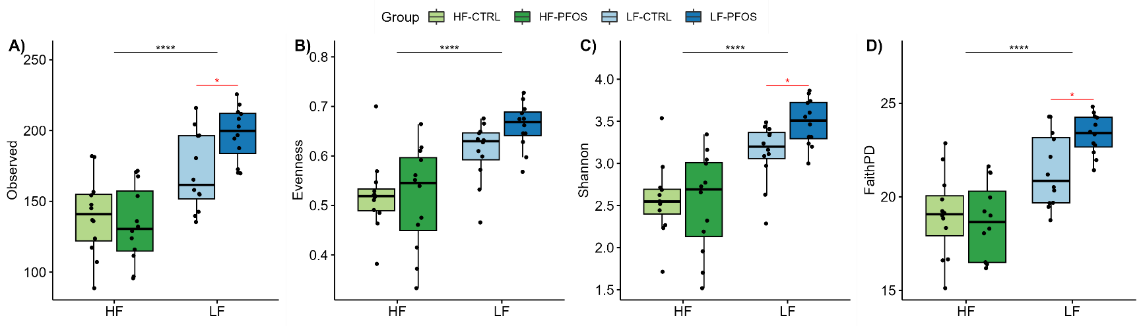

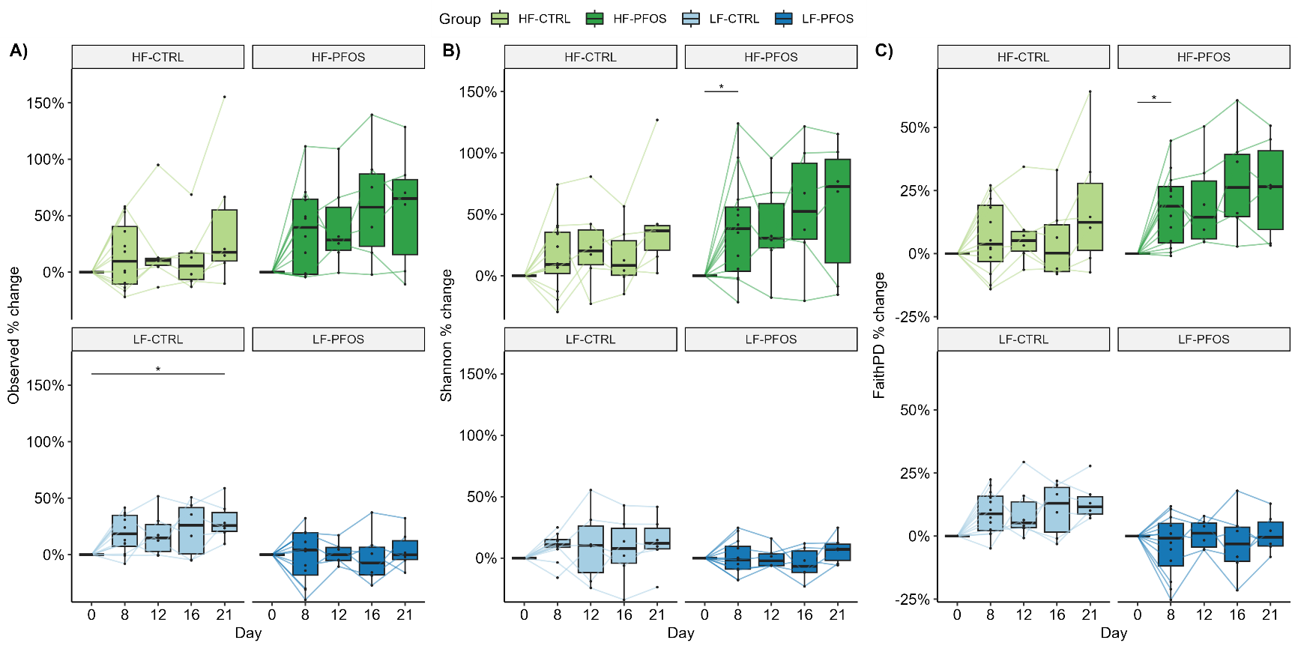

## Conclusions

Alpha-diversity in generally higher in for LF compared to HF, in the scenario where HF rats have been acclimatized to LF over a period of 7 days.  
Alpha-diversity show a significant PFOS-driven increase in Shannon diversity index and FaithPD in HF in line with previous observations (Lykkebo et al 2023), while PFOS does not seem to affect alpha-diversity in LF fed rats taken an initial bias into account.

Beta-diversity is significantly different between diet groups at all measured timepoints.  
Longitudinally, the largest ***time***-driven difference is between Day 0 and Day 8 in both HF and LF, while it should be noted that there is a initial bias in the LF data on Day 0 in unweighted UniFrac.  
Significant PFOS-driven effects are observed in unweighted metrices (Jaccard and unweighted UniFrac) in HF over the majority of the study period (including day 0), which is in line with observations from a previous study. The beta-diversity over the wash-out period in HF rats are stable within each group.  
Taking Day 0 out of the LF data and only looking at the wash-out period, show a PFOS-driven impact on beta-diversity between LF-CTRL and LF-PFOS, while the diversity between each group is generally stable in the wash-out period.

PFOS therefore increases HF alpha-diversity and based on beta-diversity metrices seems to affect the lesser abundant species.  
PFOS does not affect alpha-diversity in measurable way in LF, however, significantly affects beta-diversity on both abundant and less abundant species.  
Seems like LF diet results in a microbiota in rats that are generally more susceptible to PFOS-induced changes compared to HF diet, where only low abundant species are affected. This suggests that HF-microbiota is more robust to the effects of PFOS or that HF diet itself has a way of protecting the gut bacteria from exposure to PFOS directly (for instance by incapsulating PFOS in fibrous gel in the GI content?? This is in line with the clearly higher carrying capacity of HF diet over LF diet measured in µg PFOS per gram content).

# Cecum

## All data

Running PCoA and PERMANOVA on all Cecum samples show that the strongest factor affecting distance in beta-diversity was ***diet*** on all metrices (p < 0.001), while ***day*** also affected generally on Bray-Curtis and Jaccard metrices (p < 0.05). ***PFOS*** exposure does not seem to impact on its own, but does have a significant impact as nested with ***feed:PFOS*** in Bray-Curtis.

Conclusion: Diet has a significant impact on beta-diversity in the cecum while time of sampling also impact. Should be noted that samples here were collected during dissection and are therefore not paired.

|  |  |
| --- | --- |
| **Cecum** | |
| **Bray-Curtis** | **Jaccard** |
|  |  |
| adonis2(formula = dist.used ~ day * feed * PFOS, data = mdat, permutations = 999, na.action = na.omit)  Df SumOfSqs R2 F Pr(>F)  day 1 0.4083 0.03424 2.3202 0.032 *  feed 1 3.0897 0.25908 17.5568 0.001 ***  PFOS 1 0.3129 0.02624 1.7782 0.072 .  day:feed 1 0.2955 0.02478 1.6794 0.101  day:PFOS 1 0.2711 0.02273 1.5404 0.118  feed:PFOS 1 0.4245 0.03559 2.4120 0.025 *  day:feed:PFOS 1 0.2601 0.02181 1.4779 0.149  Residual 39 6.8632 0.57552  Total 46 11.9253 1.00000  ---  Signif. codes: 0 ‘***’ 0.001 ‘**’ 0.01 ‘*’ 0.05 ‘.’ 0.1 ‘ ’ 1 | adonis2(formula = dist.used ~ day * feed * PFOS, data = mdat, permutations = 999, na.action = na.omit)  Df SumOfSqs R2 F Pr(>F)  day 1 0.2477 0.03085 1.6797 0.050 *  feed 1 1.0396 0.12952 7.0511 0.001 ***  PFOS 1 0.1921 0.02393 1.3028 0.161  day:feed 1 0.1624 0.02023 1.1011 0.296  day:PFOS 1 0.2231 0.02780 1.5134 0.071 .  feed:PFOS 1 0.2124 0.02646 1.4404 0.089 .  day:feed:PFOS 1 0.1992 0.02481 1.3508 0.131  Residual 39 5.7503 0.71639  Total 46 8.0267 1.00000  ---  Signif. codes: 0 ‘***’ 0.001 ‘**’ 0.01 ‘*’ 0.05 ‘.’ 0.1 ‘ ’ 1 |
| **Weighted UniFrac** | **(unweighted) UniFrac** |
|  |  |
| adonis2(formula = dist.used ~ day * feed * PFOS, data = mdat, permutations = 999, na.action = na.omit)  Df SumOfSqs R2 F Pr(>F)  day 1 0.0778 0.01580 0.8335 0.466  feed 1 0.5625 0.11430 6.0286 0.001 ***  PFOS 1 0.1879 0.03819 2.0143 0.071 .  day:feed 1 0.2255 0.04581 2.4163 0.049 *  day:PFOS 1 0.0954 0.01939 1.0225 0.366  feed:PFOS 1 0.0803 0.01633 0.8611 0.449  day:feed:PFOS 1 0.0528 0.01073 0.5659 0.712  Residual 39 3.6389 0.73944  Total 46 4.9212 1.00000  ---  Signif. codes: 0 ‘***’ 0.001 ‘**’ 0.01 ‘*’ 0.05 ‘.’ 0.1 ‘ ’ 1 | adonis2(formula = dist.used ~ day * feed * PFOS, data = mdat, permutations = 999, na.action = na.omit)  Df SumOfSqs R2 F Pr(>F)  day 1 0.07509 0.02488 1.4438 0.123  feed 1 0.56479 0.18713 10.8591 0.001 ***  PFOS 1 0.06503 0.02155 1.2503 0.197  day:feed 1 0.06025 0.01996 1.1584 0.263  day:PFOS 1 0.07452 0.02469 1.4329 0.128  feed:PFOS 1 0.08373 0.02774 1.6099 0.080 .  day:feed:PFOS 1 0.06640 0.02200 1.2766 0.186  Residual 39 2.02842 0.67205  Total 46 3.01824 1.00000  ---  Signif. codes: 0 ‘***’ 0.001 ‘**’ 0.01 ‘*’ 0.05 ‘.’ 0.1 ‘ ’ 1 |

## Split by diet:

Running the same analysis by each diet we gain a better picture of the impact of PFOS and time themselves. Here HF is impacted significantly by PFOS on Bray-Curtis and unweighted UniFrac, while being close to significant in both Jaccard and Weighted UniFrac.  
No difference is seen over time suggesting that the microbiota diversity is stable in the cecum in each treatment group.

|  |  |
| --- | --- |
| **Cecum HF** | |
| **Bray-Curtis** | **Jaccard** |
|  |  |
| adonis2(formula = dist.used ~ day * PFOS, data = mdat, permutations = 999, na.action = na.omit)  Df SumOfSqs R2 F Pr(>F)  day 1 0.2684 0.05100 1.3139 0.239  PFOS 1 0.5861 0.11136 2.8689 0.020 *  day:PFOS 1 0.3229 0.06135 1.5806 0.162  Residual 20 4.0856 0.77630  Total 23 5.2630 1.00000  ---  Signif. codes: 0 ‘***’ 0.001 ‘**’ 0.01 ‘*’ 0.05 ‘.’ 0.1 ‘ ’ 1 | adonis2(formula = dist.used ~ day * PFOS, data = mdat, permutations = 999, na.action = na.omit)  Df SumOfSqs R2 F Pr(>F)  day 1 0.2445 0.06084 1.4677 0.097 .  PFOS 1 0.2610 0.06495 1.5670 0.071 .  day:PFOS 1 0.1817 0.04521 1.0907 0.290  Residual 20 3.3313 0.82900  Total 23 4.0184 1.00000  ---  Signif. codes: 0 ‘***’ 0.001 ‘**’ 0.01 ‘*’ 0.05 ‘.’ 0.1 ‘ ’ 1 |
| **Weighted UniFrac** | **(unweighted) UniFrac** |
|  |  |
| adonis2(formula = dist.used ~ day * PFOS, data = mdat, permutations = 999, na.action = na.omit)  Df SumOfSqs R2 F Pr(>F)  day 1 0.13094 0.05094 1.2220 0.288  PFOS 1 0.23099 0.08987 2.1557 0.096 .  day:PFOS 1 0.06541 0.02545 0.6104 0.626  Residual 20 2.14301 0.83374  Total 23 2.57035 1.00000  ---  Signif. codes: 0 ‘***’ 0.001 ‘**’ 0.01 ‘*’ 0.05 ‘.’ 0.1 ‘ ’ 1 | adonis2(formula = dist.used ~ day * PFOS, data = mdat, permutations = 999, na.action = na.omit)  Df SumOfSqs R2 F Pr(>F)  day 1 0.09194 0.06106 1.5029 0.107  PFOS 1 0.12709 0.08441 2.0775 0.028 *  day:PFOS 1 0.06308 0.04190 1.0311 0.370  Residual 20 1.22351 0.81263  Total 23 1.50563 1.00000  ---  Signif. codes: 0 ‘***’ 0.001 ‘**’ 0.01 ‘*’ 0.05 ‘.’ 0.1 ‘ ’ 1 |

The picture in LF microbiota show no impact from PFOS, while time is the only significant factor as seen in Bray-Curtis.

|  |  |
| --- | --- |
| **Cecum LF** | |
| **Bray-Curtis** | **Jaccard** |
|  |  |
| adonis2(formula = dist.used ~ day * PFOS, data = mdat, permutations = 999, na.action = na.omit)  Df SumOfSqs R2 F Pr(>F)  day 1 0.4347 0.12148 2.9733 0.002 **  PFOS 1 0.1675 0.04681 1.1456 0.313  day:PFOS 1 0.1983 0.05541 1.3563 0.186  Residual 19 2.7776 0.77630  Total 22 3.5780 1.00000  ---  Signif. codes: 0 ‘***’ 0.001 ‘**’ 0.01 ‘*’ 0.05 ‘.’ 0.1 ‘ ’ 1 | adonis2(formula = dist.used ~ day * PFOS, data = mdat, permutations = 999, na.action = na.omit)  Df SumOfSqs R2 F Pr(>F)  day 1 0.12941 0.04720 1.0886 0.372  PFOS 1 0.15193 0.05541 1.2780 0.226  day:PFOS 1 0.20175 0.07358 1.6970 0.057 .  Residual 19 2.25875 0.82381  Total 22 2.74183 1.00000  ---  Signif. codes: 0 ‘***’ 0.001 ‘**’ 0.01 ‘*’ 0.05 ‘.’ 0.1 ‘ ’ 1 |
| **Weighted UniFrac** | **(unweighted) UniFrac** |
|  |  |
| adonis2(formula = dist.used ~ day * PFOS, data = mdat, permutations = 999, na.action = na.omit)  Df SumOfSqs R2 F Pr(>F)  day 1 0.16535 0.09290 2.1109 0.098 .  PFOS 1 0.04717 0.02650 0.6023 0.655  day:PFOS 1 0.07909 0.04444 1.0098 0.374  Residual 19 1.48824 0.83616  Total 22 1.77986 1.00000  ---  Signif. codes: 0 ‘***’ 0.001 ‘**’ 0.01 ‘*’ 0.05 ‘.’ 0.1 ‘ ’ 1 | adonis2(formula = dist.used ~ day * PFOS, data = mdat, permutations = 999, na.action = na.omit)  Df SumOfSqs R2 F Pr(>F)  day 1 0.04456 0.05212 1.1839 0.252  PFOS 1 0.05189 0.06068 1.3784 0.143  day:PFOS 1 0.04339 0.05074 1.1526 0.264  Residual 19 0.71518 0.83646  Total 22 0.85501 1.00000 |

## Alpha-diversity

Considering alpha-diversity on top of beta-diversity is essential. Here we observe that alpha-diversity is generally higher in LF compared to HF on both Day 8 and 21 on all metrices. The only exception is for Faith’s phylogenetic diversity on Day 21, where we see a significant difference between LF-CTRL and LF-PFOS and a slight trend towards higher values in LF-PFOS for observed number of species and Shannon diversity index.  
Generally the levels of diversity in each metric does not differ much for each group over time, though LF-CTRL and HF-groups get close to each other over time.  
No differences are observed between HF-CTRL and Hf-PFOS, suggesting that PFOS has no measurable impact on caecal alpha-diversity, despite the measurement of ΣPFOS in caecal content of approx. 1.5 µg/g and 0.9 µg/g on Day 8 and 1.2 µg/g and 0.7 µg/g on Day 21 for HF and LF, respectively.

This generally suggests that LF diet increases alpha-diversity compared to HF-groups which equals closer to LF-CTRL over time. PFOS has no measurable effect on HF diet while seemingly increase the diversity in LF-PFOS over time compared to LF-CTRL.

## Conclusions

Generally, the caecal alpha- and beta-diversity are significantly affected by diet, with the same going for the caecal content consistency and size of caecum also observed markedly different between HF and LF.  
Taking diet out of the equation reveals a slightly significant impact from PFOS in HF using Bray-Curtis and unweighted UniFrac and close to significant impact in weighted Unifrac and Jaccard, while time only has a significant impact in Bray-Curtis and Jaccard metrices. In LF, time as a factor is only significant using Bray-Curtis while PFOS expose has no effect on beta diversity. This is interesting as alpha-diversity seems to be slightly affected by PFOS on Day 21 and that HF is unaffected by PFOS.

This suggests that caecal microbiota generally has higher alpha-diversity in LF fed rats while it is only affected by PFOS on beta-diversity on the HF group and in alpha-diversity on Day 21 in the LF group, where phylogenetic diversity seems to be higher.

# Ileum

## All data

Analysis of all data from ileum show that diet has the greatest impact on beta-diversity on ileal content of all factors included in the PERMANOVA (p = 0.001-0.36), while PFOS expose show significant impact on weighted metrices only (Bray-Curtis and Weighted UniFrac).

This shows that diet has the largest impact on ileal microbiota and suggests that PFOS impacts the diversity in the ileum to a smaller degree and mainly on the more abundant species as unweighted metrices show not effect.

|  |  |
| --- | --- |
| **Ileum** | |
| **Bray-Curtis** | **Jaccard** |
|  |  |
| adonis2(formula = dist.used ~ day * feed * PFOS, data = mdat, permutations = 999, na.action = na.omit)  Df SumOfSqs R2 F Pr(>F)  day 1 0.2715 0.03748 2.8551 0.052 .  feed 1 2.6603 0.36725 27.9764 0.001 ***  PFOS 1 0.4138 0.05712 4.3515 0.016 *  day:feed 1 0.1114 0.01538 1.1719 0.260  day:PFOS 1 0.0650 0.00898 0.6838 0.509  feed:PFOS 1 0.0668 0.00922 0.7020 0.507  day:feed:PFOS 1 0.1367 0.01888 1.4379 0.207  Residual 37 3.5184 0.48570  Total 44 7.2439 1.00000  ---  Signif. codes: 0 ‘***’ 0.001 ‘**’ 0.01 ‘*’ 0.05 ‘.’ 0.1 ‘ ’ 1 | adonis2(formula = dist.used ~ day * feed * PFOS, data = mdat, permutations = 999, na.action = na.omit)  Df SumOfSqs R2 F Pr(>F)  day 1 0.2348 0.02254 1.0180 0.388  feed 1 0.4519 0.04339 1.9595 0.011 *  PFOS 1 0.2830 0.02718 1.2271 0.174  day:feed 1 0.2545 0.02444 1.1035 0.247  day:PFOS 1 0.2176 0.02089 0.9435 0.505  feed:PFOS 1 0.2100 0.02016 0.9105 0.558  day:feed:PFOS 1 0.2292 0.02201 0.9937 0.400  Residual 37 8.5338 0.81938  Total 44 10.4148 1.00000  ---  Signif. codes: 0 ‘***’ 0.001 ‘**’ 0.01 ‘*’ 0.05 ‘.’ 0.1 ‘ ’ 1 |
| **Weighted UniFrac** | **(unweighted) UniFrac** |
|  |  |
| adonis2(formula = dist.used ~ day * feed * PFOS, data = mdat, permutations = 999, na.action = na.omit)  Df SumOfSqs R2 F Pr(>F)  day 1 0.06984 0.03446 2.7036 0.066 .  feed 1 0.76652 0.37817 29.6727 0.001 ***  PFOS 1 0.11574 0.05710 4.4803 0.006 **  day:feed 1 0.03473 0.01713 1.3443 0.233  day:PFOS 1 0.01849 0.00912 0.7157 0.525  feed:PFOS 1 0.02700 0.01332 1.0451 0.314  day:feed:PFOS 1 0.03881 0.01915 1.5025 0.187  Residual 37 0.95580 0.47155  Total 44 2.02692 1.00000  ---  Signif. codes: 0 ‘***’ 0.001 ‘**’ 0.01 ‘*’ 0.05 ‘.’ 0.1 ‘ ’ 1 | adonis2(formula = dist.used ~ day * feed * PFOS, data = mdat, permutations = 999, na.action = na.omit)  Df SumOfSqs R2 F Pr(>F)  day 1 0.1321 0.02469 1.1118 0.284  feed 1 0.2536 0.04742 2.1351 0.036 *  PFOS 1 0.1583 0.02959 1.3323 0.158  day:feed 1 0.0996 0.01861 0.8382 0.562  day:PFOS 1 0.0961 0.01796 0.8089 0.610  feed:PFOS 1 0.1159 0.02168 0.9760 0.380  day:feed:PFOS 1 0.0983 0.01838 0.8275 0.580  Residual 37 4.3954 0.82168  Total 44 5.3493 1.00000  ---  Signif. codes: 0 ‘***’ 0.001 ‘**’ 0.01 ‘*’ 0.05 ‘.’ 0.1 ‘ ’ 1 |

## Split by diet

Splitting by diet helps focus on the significance of ***time*** and ***PFOS*** exposure. Here we see that there is no impact from neither factors on HF diet, suggesting that HF microbiota is quite stable over time as well as unaffected by the presence of PFOS.

|  |  |
| --- | --- |
| **Ileum HF** | |
| **Bray-Curtis** | **Jaccard** |
|  |  |
| adonis2(formula = dist.used ~ day * PFOS, data = mdat, permutations = 999, na.action = na.omit)  Df SumOfSqs R2 F Pr(>F)  day 1 0.17469 0.05600 1.3268 0.239  PFOS 1 0.22315 0.07154 1.6948 0.136  day:PFOS 1 0.08819 0.02827 0.6698 0.640  Residual 20 2.63329 0.84419  Total 23 3.11932 1.00000 | adonis2(formula = dist.used ~ day * PFOS, data = mdat, permutations = 999, na.action = na.omit)  Df SumOfSqs R2 F Pr(>F)  day 1 0.2535 0.04564 1.0323 0.355  PFOS 1 0.1990 0.03583 0.8104 0.760  day:PFOS 1 0.1901 0.03424 0.7743 0.778  Residual 20 4.9108 0.88429  Total 23 5.5534 1.00000 |
| **Weighted UniFrac** | **(unweighted) UniFrac** |
|  |  |
| adonis2(formula = dist.used ~ day * PFOS, data = mdat, permutations = 999, na.action = na.omit)  Df SumOfSqs R2 F Pr(>F)  day 1 0.04311 0.05268 1.2476 0.222  PFOS 1 0.06334 0.07739 1.8330 0.097 .  day:PFOS 1 0.02090 0.02554 0.6050 0.674  Residual 20 0.69112 0.84440  Total 23 0.81848 1.00000  ---  Signif. codes: 0 ‘***’ 0.001 ‘**’ 0.01 ‘*’ 0.05 ‘.’ 0.1 ‘ ’ 1 | adonis2(formula = dist.used ~ day * PFOS, data = mdat, permutations = 999, na.action = na.omit)  Df SumOfSqs R2 F Pr(>F)  day 1 0.18301 0.06481 1.4782 0.116  PFOS 1 0.07548 0.02673 0.6097 0.893  day:PFOS 1 0.08938 0.03165 0.7220 0.760  Residual 20 2.47615 0.87682  Total 23 2.82402 1.00000 |

Looking at LF diet, we see significant impact from both ***PFOS*** exposure and ***time*** on the weighted metrices (Bray-Curtis and Weighted UniFrac), while unweighted metrices show no impacts. This suggests that the same conclusions draw in cecum can be applied here: PFOS exposure affects the ileal microbiota slightly and on the more abundant species as unweighted metrices are unaffected.

|  |  |
| --- | --- |
| **Ileum LF** | |
| **Bray-Curtis** | **Jaccard** |
|  |  |
| adonis2(formula = dist.used ~ day * PFOS, data = mdat, permutations = 999, na.action = na.omit)  Df SumOfSqs R2 F Pr(>F)  day 1 0.17869 0.12476 3.4322 0.042 *  PFOS 1 0.25392 0.17728 4.8771 0.011 *  day:PFOS 1 0.11462 0.08002 2.2015 0.129  Residual 17 0.88507 0.61794  Total 20 1.43229 1.00000  ---  Signif. codes: 0 ‘***’ 0.001 ‘**’ 0.01 ‘*’ 0.05 ‘.’ 0.1 ‘ ’ 1 | adonis2(formula = dist.used ~ day * PFOS, data = mdat, permutations = 999, na.action = na.omit)  Df SumOfSqs R2 F Pr(>F)  day 1 0.2382 0.05379 1.1122 0.285  PFOS 1 0.2937 0.06630 1.3709 0.137  day:PFOS 1 0.2559 0.05776 1.1944 0.240  Residual 17 3.6415 0.82215  Total 20 4.4293 1.00000 |
| **Weighted UniFrac** | **(unweighted) UniFrac** |
|  |  |
| adonis2(formula = dist.used ~ day * PFOS, data = mdat, permutations = 999, na.action = na.omit)  Df SumOfSqs R2 F Pr(>F)  day 1 0.05419 0.12637 3.5239 0.036 *  PFOS 1 0.07703 0.17964 5.0095 0.013 *  day:PFOS 1 0.03619 0.08439 2.3533 0.105  Residual 17 0.26142 0.60961  Total 20 0.42884 1.00000  ---  Signif. codes: 0 ‘***’ 0.001 ‘**’ 0.01 ‘*’ 0.05 ‘.’ 0.1 ‘ ’ 1 | adonis2(formula = dist.used ~ day * PFOS, data = mdat, permutations = 999, na.action = na.omit)  Df SumOfSqs R2 F Pr(>F)  day 1 0.07961 0.03405 0.7133 0.669  PFOS 1 0.20326 0.08693 1.8211 0.081 .  day:PFOS 1 0.15799 0.06757 1.4155 0.182  Residual 17 1.89746 0.81146  Total 20 2.33833 1.00000  ---  Signif. codes: 0 ‘***’ 0.001 ‘**’ 0.01 ‘*’ 0.05 ‘.’ 0.1 ‘ ’ 1 |

## Alpha-diversity

Generally, alpha-diversity is barely affected by diet or PFOS in the ileum, though on Day 8 there is a larger general diversity in LF-CTRL compared to LF-PFOS , which is significant in Shannon diversity index.

## Conclusions

For ileum, the main conclusion is that diet has the largest effect on overall diversity between the groups, while PFOS treatment also has a significant impact on the weighted metrices (Bray-Curtis and Weighted UniFrac).  
Looking within each diet on their own, show that HF diet is not influenced by PFOS treatment or even time of sampling, while LF diet is significantly influenced by both time and PFOS treatment on the weighted metrices.  
On alpha-diversity the effects are less clear but there is a trend towards a PFOS-driven impact on LF diets on Day 8 (after ended dosing period).

This suggests that ileal microbiota in the LF fed rats are more susceptible to PFOS effects both generally and longitudinally compared to HF fed rats on beta-diversity, and that the effects are mainly observed on species of higher abundance in the community. Compared to the other compartments analysed, ileal content also has the lowest number of observed species and generally lower diversity scores in other alpha-diversity metrices.

# General conclusions

Generally, the main drivers of beta-diversity differences in the rats are based on the diets, which are significant in all tested scenarios involving *feed* as a factor for ileum, caecum and faeces both on individual days (not shown) and longitudinally (analysed here).  
PFOS expose has a significant impact on

# Differential abundance

## General

### Relative abundance

Looking at differential abundance in faecal microbiota revealed no PFOS-driven impact on any present taxa, while there were several differences resulting from different fibre intakes.

### Correlational analysis (Spearman)

Performing a Spearman correlation between abundance of species which differs significantly with faecal PFOS concentrations (µg/g faeces) revealed no correlations in LF fed animals while several were found in HF – this is most likely due to the significantly higher level of PFOS in faecal HF-PFOS samples than LF-PFOS, hence enforcing any possible correlation. It should also be noted that this data is from all days (except Day 0) which means that the PFOS concentration is also reflecting it’s decrease over time. Since this is the case, it also cannot be ruled out if the correlations are partially due to normal change over time – to analyse this specifically individual days should be run separately within each diet group.

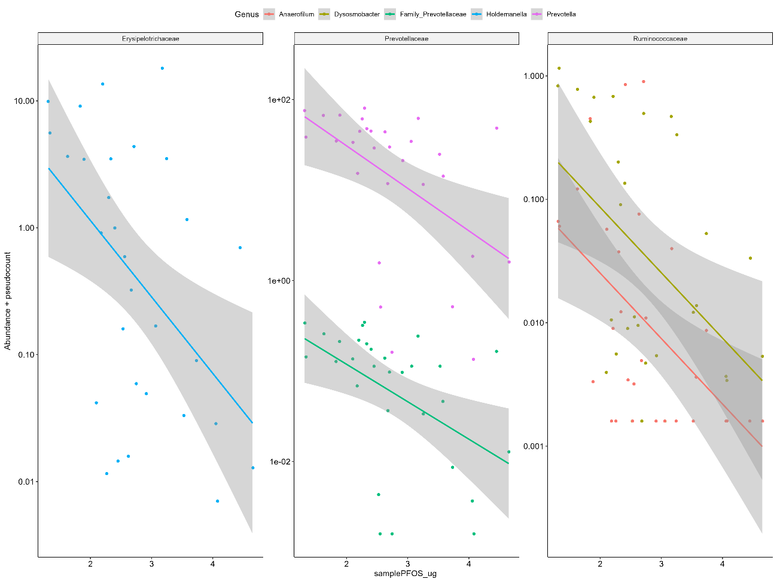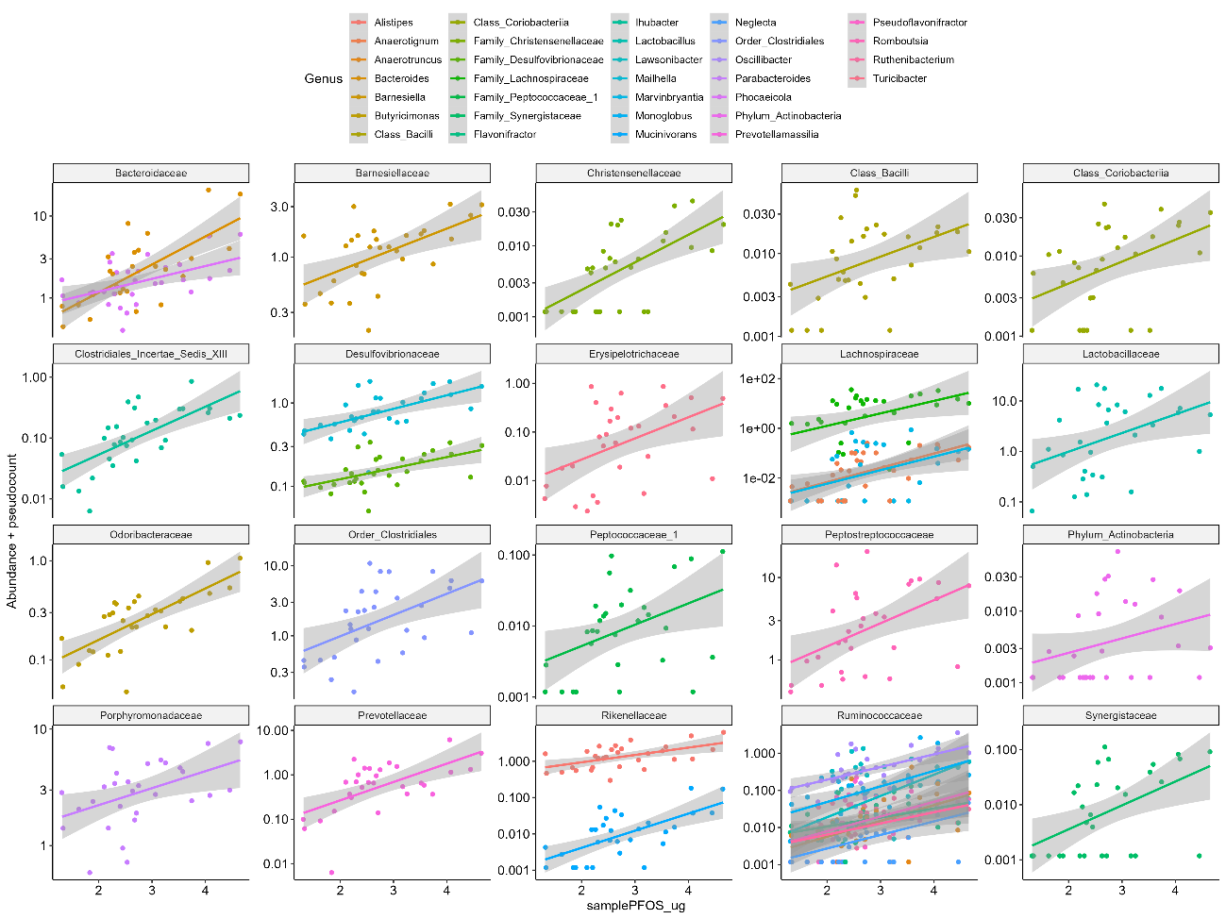

Doing this reveal almost no correlations, only on Day 21 in HF rats, where there are a positive correlation with PFOS concentration on Family level for Bifidobacteriaceae, Clostridiales_Incertae_Sedis_XIII, Peptostreptococcaceae and Staphylococcaceae, however base on a very small sample size.

The overall conclusion is therefore that it cannot be concluded if longitudinal samples show correlations to faeces sample concentration of PFOS, however, on individual sampling days it can be deducted that no taxa show direct correlation with faeces sample PFOS concentration.

## Enterobacteriaceae

As we observed a significant decline in an Enterobacteriaceae genera during a previous experiment we looked for a similar tendency in this setup.

In faeces only two genera of Enterobacteriaceae were detected (Escherichia/Shigella and Salmonella). No significant PFOS-driven differences in relative abundance were observed at any timepoint, while LF promoted a significantly higher relative abundance of Escherichia/Shigella throughout the study.

Additionally, no significant correlation was observed between *Enterobacteriaceae* genera and faecal PFOS concentrations over time. (same issue with interpretation as above)

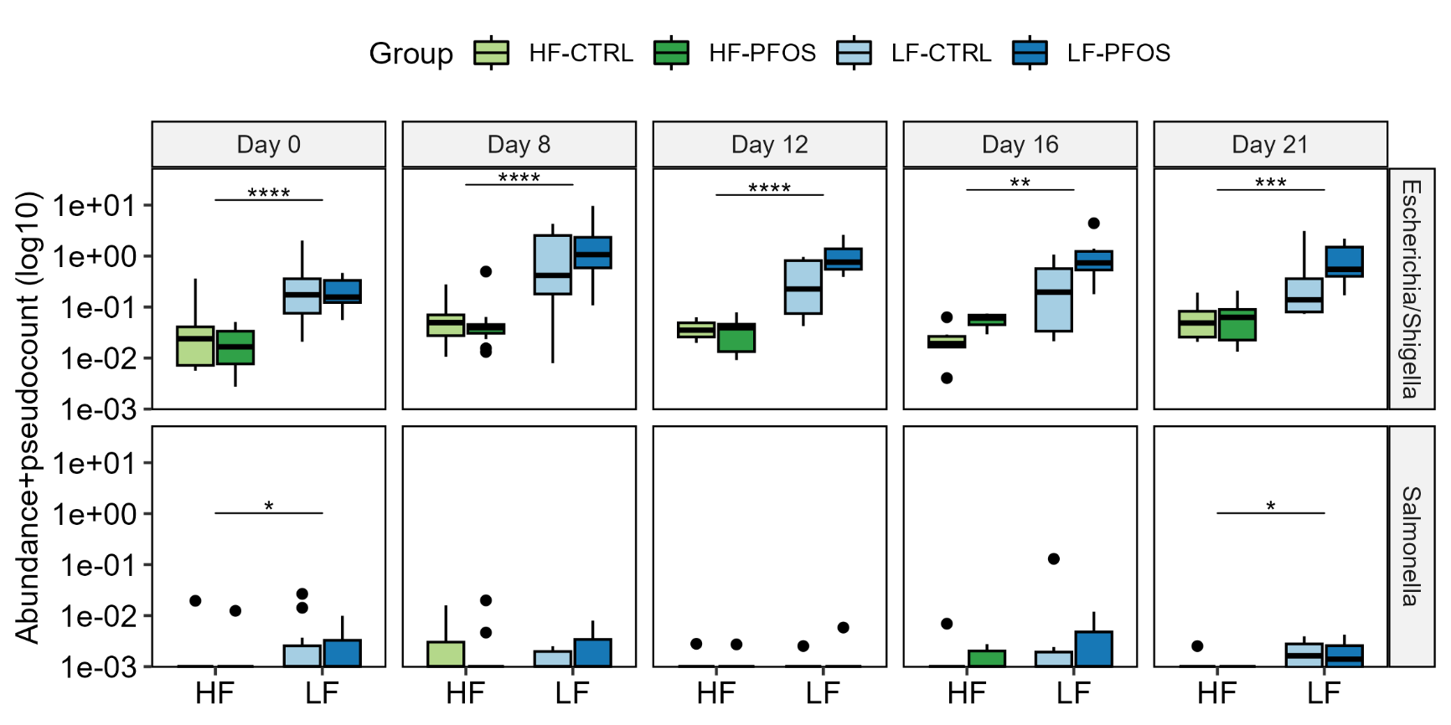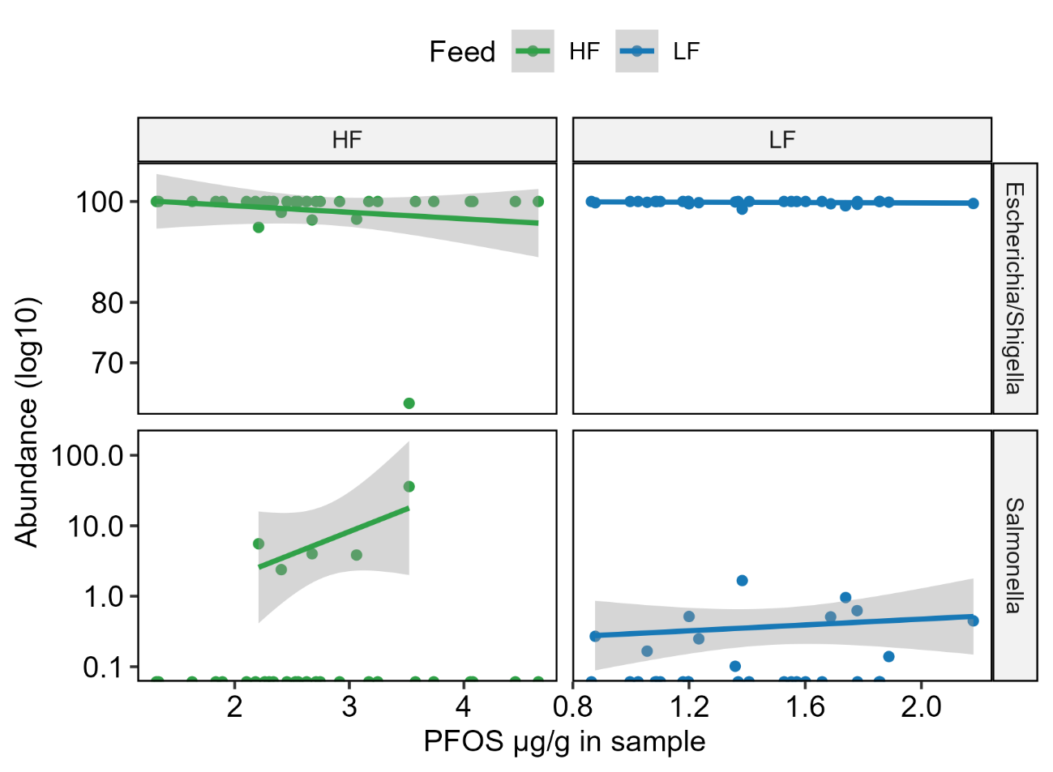

Caecal content show a similar tendency as in faeces, but with lower relative abundance of both genera.

